## Name: ________________________________________ Date: _____________________________

**CALCULUS BC**

**SECTION I, Part A**

**Time – 55 Minutes**

**Number of questions – 28**

**A CALCULATOR MAY NOT BE USED ON THIS PART OF THE EXAMINATION**

**Directions: Solve each of the following problems, using the available space for scratch work. After examining the form of the choices, decide which is the best of the choices given and fill in the corresponding oval on the answer sheet. No credit will be given for anything written in the exam book. Do not spend too much time on any one problem.**

**In this exam:**

**(1) Unless otherwise specified, the domain of a function is assumed to be the set of all real numbers**

**for which is a real number.**

**(2) The inverse of a trigonometric function may be indicated using the inverse function notation**

**or with the prefix “arc” (e.g., ).**

**__________________________________________________________________________________________**

1. The function is twice differentiable with , , and . What is the value of the approximation of using the line tangent to the graph of at ?

(A) (B) (C) (D) (E)

2. is

1. (B) (C) (D) (E) nonexistent

__________________________________________________________________________________________

3. Let be the function defined above. Which of the following statements about are true?

1. has a limit at .
2. is continuous at .
3. is differentiable at .
4. I only
5. II only
6. III only
7. I and II only
8. I, II, and III

__________________________________________________________________________________________

4. In the -plane, what is the slope of the line tangent to the graph of at the point

?

1. (B) (C) (D) (E)

__________________________________________________________________________________________

(A) (B) (C) (D) (E)

|  |  |  |  |  |  |
| --- | --- | --- | --- | --- | --- |
|  |  |  |  |  |  |
|  |  |  |  |  |  |

6. The function is continuous on the closed interval and has values as shown in the table above. Using the interval and , what is the approximation of obtained from a left rectangular approximation?

1. (B) (C) (D) (E)

__________________________________________________________________________________________

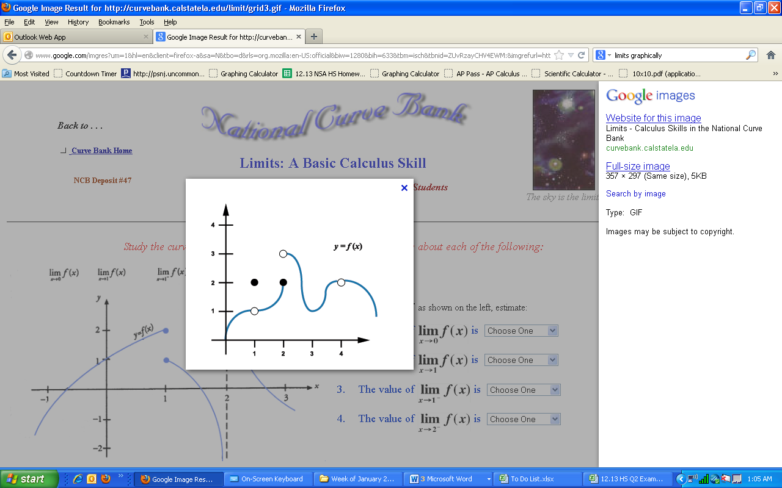

7. The graph of a function is shown above. For which of the following values of does ?

1. only
2. only
3. and only
4. and only
5. and

__________________________________________________________________________________________

8. If , what is the value of that maximizes the product ?

(A) 3 (B) 4.5 (C) 6 (D) 9 (E) 108

__________________________________________________________________________________________

9. The function is defined by . What points on the graph of have the property that the line tangent to at has slope ?

1. only
2. only
3. and
4. and
5. There are no such points.

__________________________________________________________________________________________

(A) (B) (C) (D) (E)

__________________________________________________________________________________________

11. If , then



__________________________________________________________________________________________

12.

1. (B) (C) (D) (E)

__________________________________________________________________________________________

13. If , then

1. (B) (C) (D) (E)

__________________________________________________________________________________________

14. If , then has which of the following extrema?

I. A relative maximum at

II. A relative minimum at

III. A relative maximum at

(A) I only

(B) II only

(C) I and II

(D) II and III

(E) I, II, and III

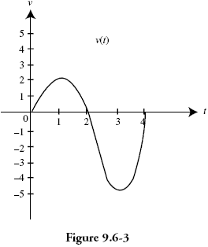

15. The velocity of a particle moving along the -axis is shown above for . The graph has horizontal tangents at and , and a zero at . For what values of is the speed of the particle decreasing?

(A) only

(B) only

(C) only

(D) and

(E) and

16. is

(A) (B) (C) (D) (E) nonexistent

17. If , then



__________________________________________________________________________________________

18. What is the *x-*coordinate of the point of inflection on the graph of

(A) – 1 (B) 1 (C) 2 (D) (E)

__________________________________________________________________________________________

19. Let and let be the inverse function of . Given that , what is the value of ?



__________________________________________________________________________________________

20. If , on which of the following intervals is concave down?



__________________________________________________________________________________________

21. Let be the function defined by . Which of the following is the equation of the line normal to the graph of at the point where ?

(A)

(B)

(C)

(D)

(E)

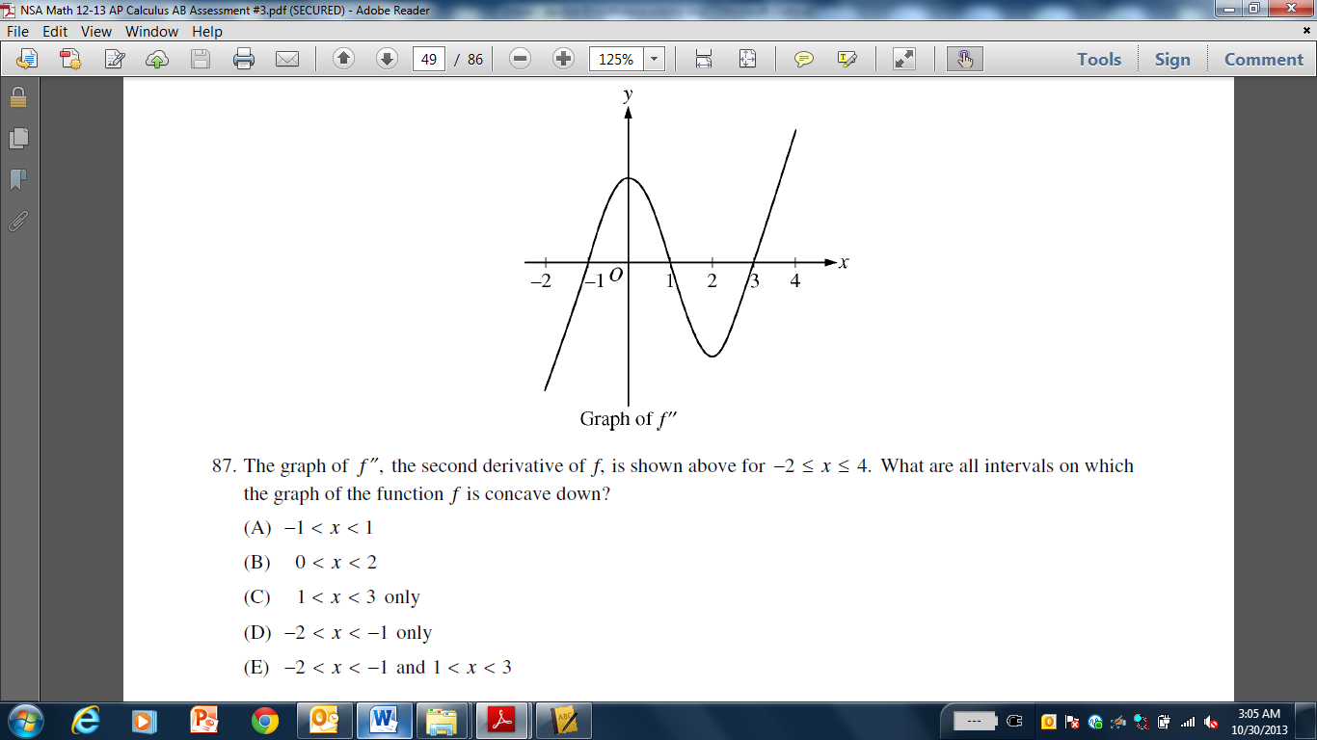

22. The graph of , the second derivative of , is shown above for . What are all intervals on

which the graph of the function is concave down?

(A)

(B)

(C) only

(D) only

(E) and

23. If , then the absolute maximum value of on the closed interval occurs when



__________________________________________________________________________________________

24. A particle moves along the -axis with its position at time given by , where

and are constants and . For which of the following values of is the particle at rest?

5. and

__________________________________________________________________________________________

25. If is differentiable at , which of the following could be false?

1. is continuous at .
2. exists.
3. exists.
4. is defined.
5. is defined.

_________________________________________________________________________________________

26. The line is a horizontal asymptote to the graph of which of the following functions?



__________________________________________________________________________________________

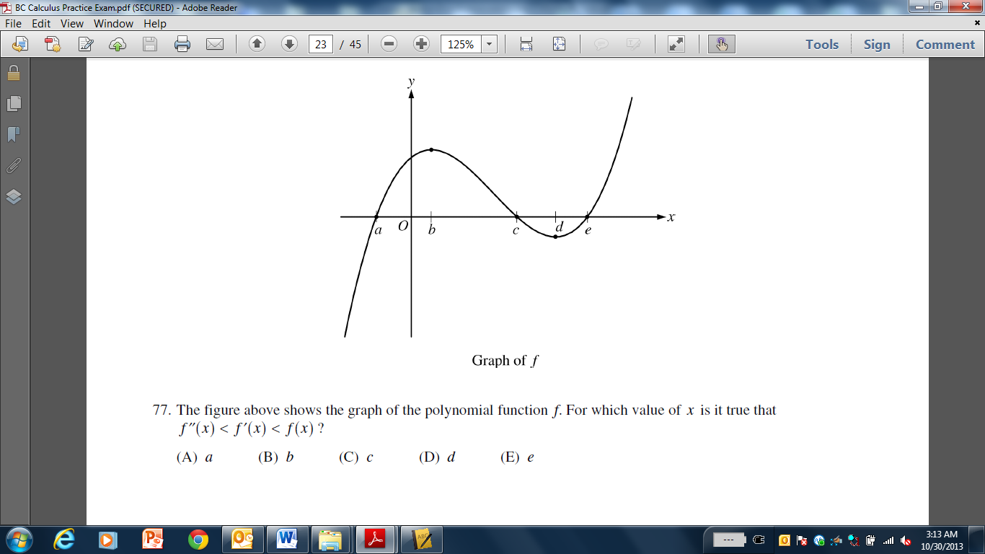

27. The figure above shows the graph of the polynomial function . For which value of is it true that ?



__________________________________________________________________________________________

28. For small values of , the function is best approximated by which of the following?



__________________________________________________________________________________________

**END OF PART A OF SECTION I**

IF YOU FINISH BEFORE TIME IS CALLED, YOU MAY CHECK YOUR WORK ON THIS PART ONLY.

DO NOT GO ON TO PART B UNTIL YOU ARE TOLD TO DO SO.

**CALCULUS BC**

**SECTION I, Part B**

**Time – 50 Minutes**

**Number of questions – 17**

**A GRAPHING CALCULATOR IS REQUIRED FOR SOME QUESTIONS**

**ON THIS PART OF THE EXAM.**

**Directions: Solve each of the following problems, using the available space for scratch work. After examining the form of the choices, decide which is the best of the choices given and fill in the corresponding oval on the answer sheet. No credit will be given for anything written in the exam book. Do not spend too much time on any one problem.**

**BE SURE YOU ARE USING PART B OF THE ANSWER SHEET   
TO RECORD YOUR ANSWERS TO QUESTIONS NUMBERED 29 – 45.**

**YOU MAY NOT RETURN TO PART A OF THE ANSWER SHEET.**

**In this exam:**

**(1) The exact numerical value of the correct answer does not always appear among the choices given. When this happens, select from among the choices the number that best approximates the exact numerical value.**

**(2) Unless otherwise specified, the domain of a function is assumed to be the set of all real**

**numbers for which is a real number.**

**(3) The inverse of a trigonometric function may be indicated using the inverse function notation or with the prefix “arc” (e.g., ).**

**__________________________________________________________________________________________**

29. Let be the function defined above, where and are constants. If is differentiable at , what is the value of ?

1. (B) (C) (D) (E)

__________________________________________________________________________________________

30. A particle moves along a straight line with velocity given by at time . What is the acceleration of the particle at time ?



__________________________________________________________________________________________

31. Let be the function given by . What is the value of that satisfies the conclusion of the Mean Value Theorem of differential calculus on the closed interval ?

1. (B) (C) (D) (E)

__________________________________________________________________________________________

32. A particle moves on the -axis with velocity given by for . How many times does the particle change direction as increases from to ?

1. Zero (B) One (C) Two (D) Three (E) Four

__________________________________________________________________________________________

33. The radius of a sphere is increasing at the uniform rate of inches per second. At the instant when the surface area becomes square inches, what is the rate of increase, in cubic inches per second, in the volume ?

1. (B) (C) (D) (E)

__________________________________________________________________________________________

34. The function is continuous on the closed interval and twice differentiable on the open interval

. If and on the open interval , which of the following could be a table of values for ?

1. (B) (C) (D) (E)

|  |  |
| --- | --- |
|  |  |
| 7 | 12 |
| 8 | 16 |
| 9 | 18 |

|  |  |
| --- | --- |
|  |  |
| 7 | 1 |
| 8 | 5 |
| 9 | 13 |

|  |  |
| --- | --- |
|  |  |
| 7 | 9 |
| 8 | 8 |
| 9 | 7 |

|  |  |
| --- | --- |
|  |  |
| 7 | 12 |
| 8 | 8 |
| 9 | 0 |

|  |  |
| --- | --- |
|  |  |
| 7 | 20 |
| 8 | 12 |
| 9 | 10 |

__________________________________________________________________________________________

35. If , then



__________________________________________________________________________________________

36. The derivative of the function is given by How many points of inflection does the graph of have on the open interval

1. One (B) Four (C) Five (D) Six (E) Seven

__________________________________________________________________________________________

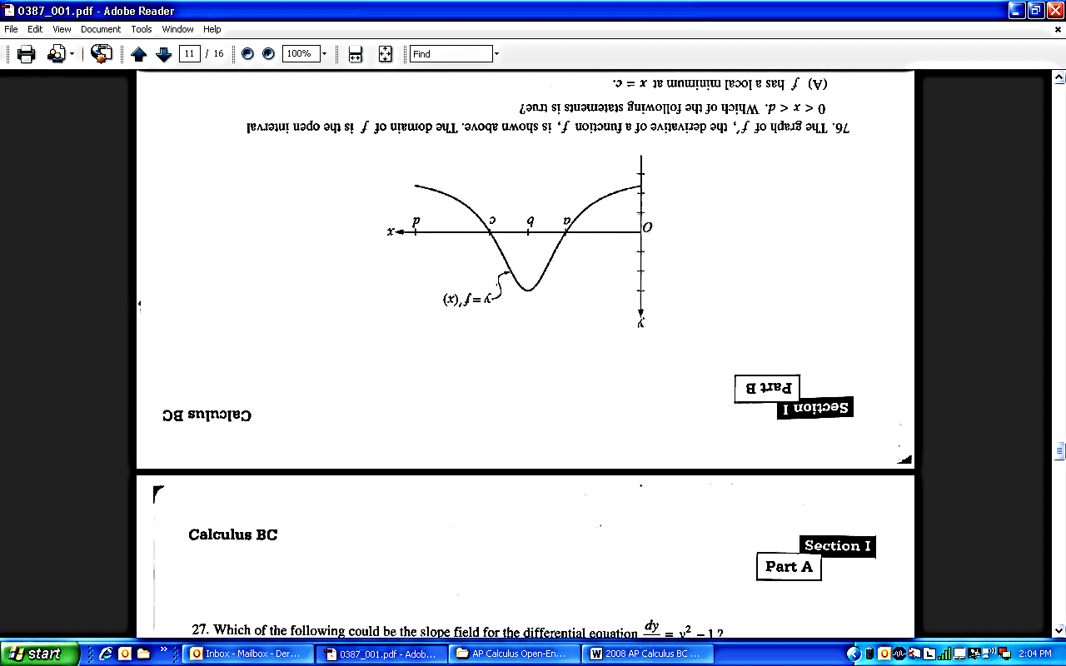

37. The graph of , the derivative of a function , is shown above. The domain of is the open interval . Which of the following statements is true?

1. has a local minimum at .
2. has a local maximum at .
3. The graph of has a point of inflection at .
4. The graph of has a point of inflection at
5. The graph of is concave up on the open interval .

__________________________________________________________________________________________



__________________________________________________________________________________________

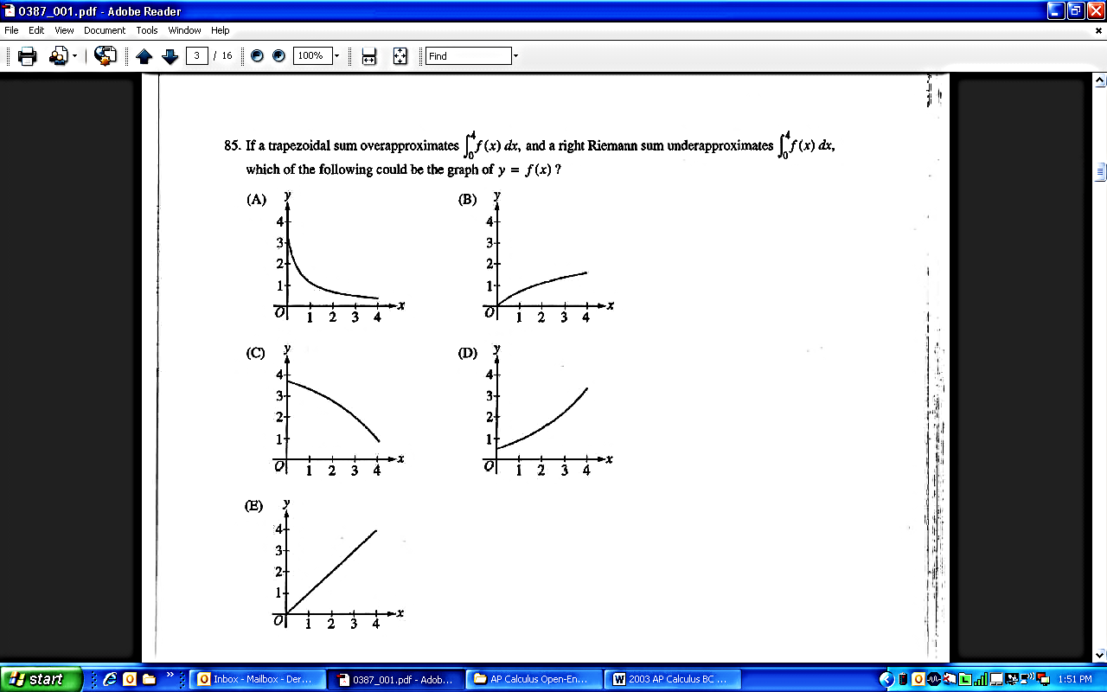

39. The graph of the function is shown above for . Of the following, which has the least value?

2. Left Riemann sum approximation of with 4 subintervals of equal length.
3. Right Riemann sum approximation of with 4 subintervals of equal length.
4. Midpoint Riemann sum approximation of with 4 subintervals of equal length.
5. Not enough information to determine which has the least value.

__________________________________________________________________________________________

40. Let be a function that is continuous on the closed interval with and .

Which of the following is guaranteed by the Intermediate Value Theorem?

1. has at least one solution in the open interval .
2. .
3. attains a maximum on the open interval .
4. has at least one solution in the open interval .
5. for all in the open interval .

__________________________________________________________________________________________

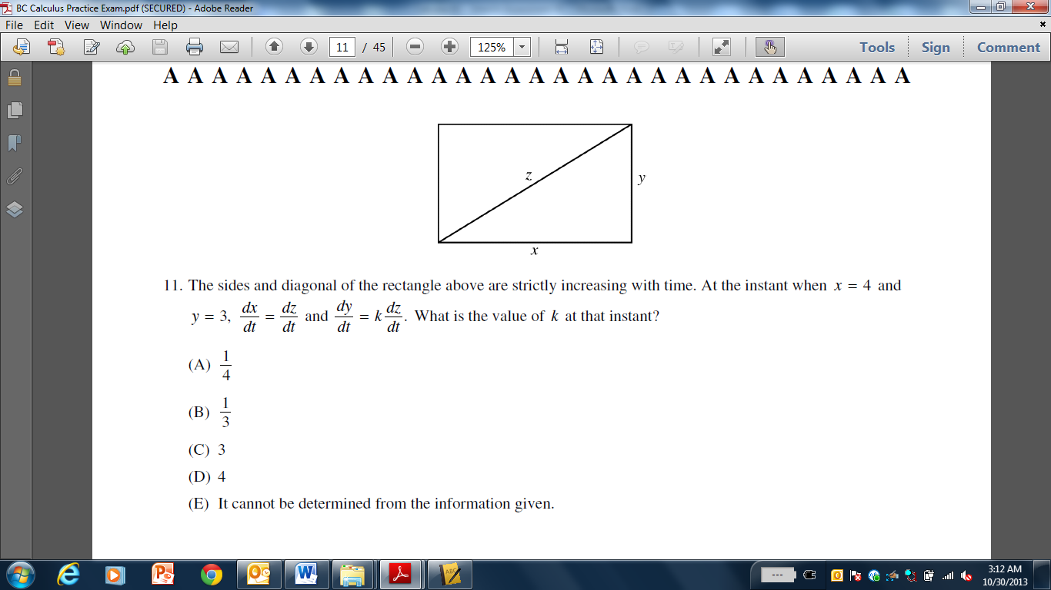

41. The sides and diagonal of the rectangle above are strictly increasing with time. At the instant when and , and . What is the value of at that instant?

5. It cannot be determined from the information given.

__________________________________________________________________________________________

42. Consider the functions and given by and . At what value of do the graphs of and have perpendicular tangent lines?

(A)

(B)

(C)

(D)

(E)

__________________________________________________________________________________________

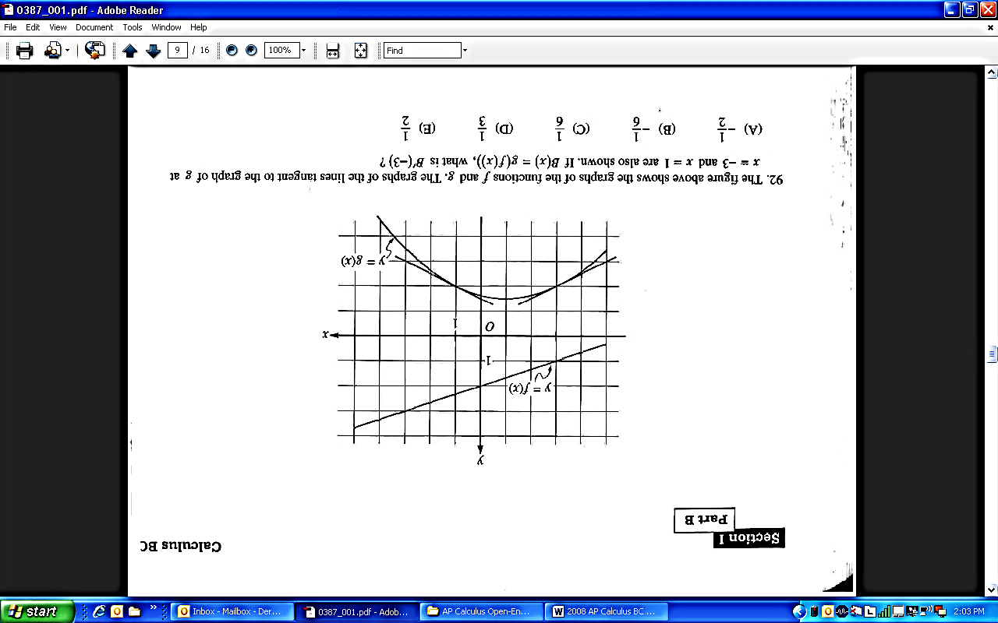

43. The figure above shows the graphs of the functions and . The graphs of the lines tangent to the graphs of at and are also shown. If what is ?

1. (B) (C) (D) (E)

__________________________________________________________________________________________

44. The volume of a cylindrical tin can with a top and a bottom is to be cubic inches. If a minimum amount of tin is to be used to construct the can, what must be the radius, in inches, of the can?



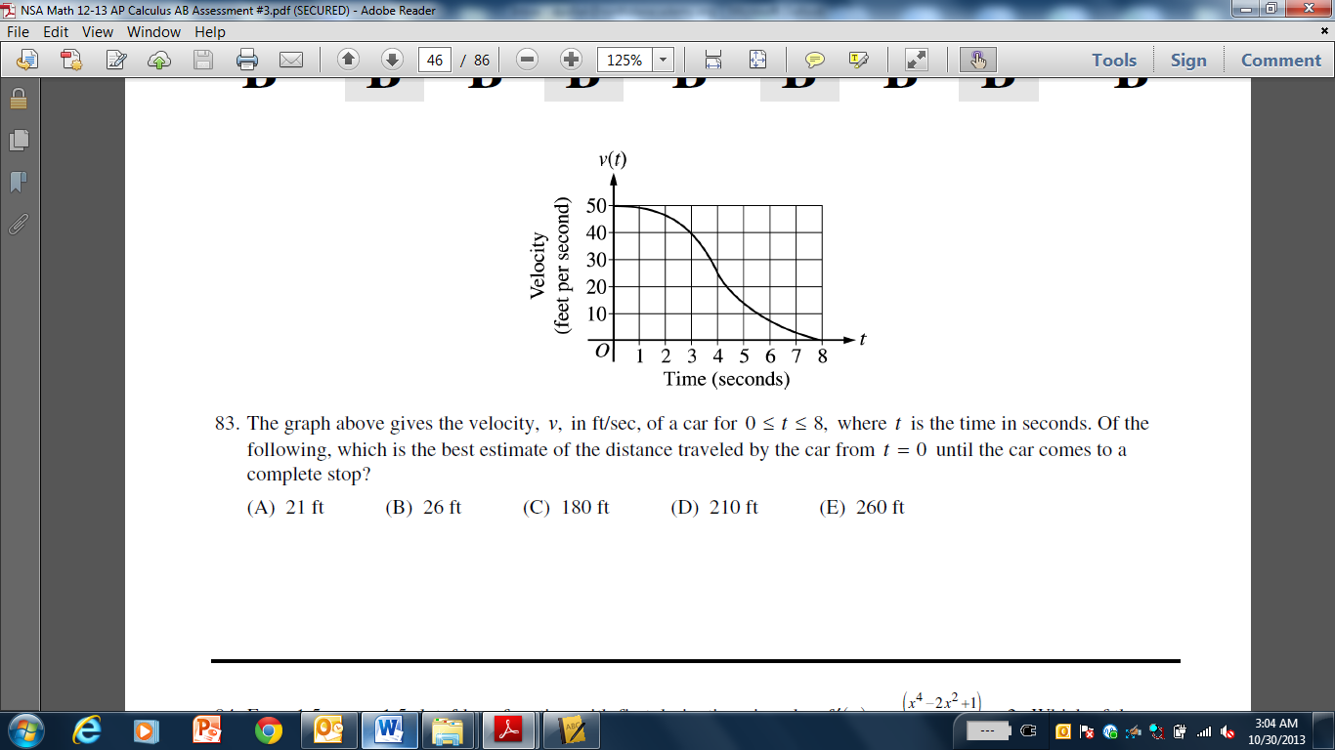

45. The graph above gives the velocity, , in ft/sec, of a car for , where is the time in seconds. Of the following, which is the best estimate of the distance traveled by the car from until the car comes to a complete stop?

1. ft
2. ft
3. ft
4. ft
5. ft

__________________________________________________________________________________________

**END OF SECTION I**

IF YOU FINISH BEFORE TIME IS CALLED, YOU MAY CHECK YOUR WORK ON PART B ONLY.

DO NOT GO ON TO SECTION II UNTIL YOU ARE TOLD TO DO SO.

**CALCULUS BC**

**SECTION II, Part A**

**Time – 30 Minutes**

**Number of problems – 2**

**A graphing calculator is required for some problems or parts of problems.**

__________________________________________________________________________________________

1. Consider the curve known as the Folium of Descartes, given by the equation .

(a) Show that . .

(b) Find the coordinate(s) of all points on the curve for which the tangent line is vertical.

(c) Find the equation of the line tangent to the curve at the point .

(d) Let and be functions of time that are related by the equation . At time , the values of and . Find the value of at time .

__________________________________________________________________________________________

|  |  |  |  |  |  |  |
| --- | --- | --- | --- | --- | --- | --- |
| (minutes) | 0 | 2 | 5 | 7 | 11 | 12 |
| (feet per minute) | 5.7 | 4.0 | 2.0 | 1.2 | 0.6 | 0.5 |

2. The volume of a spherical hot air balloon expands as the air inside the balloon is heated. The radius of the balloon, in feet, is modeled by a twice-differentiable function of time , where is measured in minutes. For , the graph of is concave down. The table above gives selected values of the

rate of change, , of the radius of the balloon over the time interval . The radius of the balloon is 30 feet when .

(a) Approximate the value of . Indicate units of measure.

(b) Find the rate of change of the volume of the balloon with respect to time when . Indicate

units of measure.

(c) Use a right Riemann sum with the five subintervals indicated by the data in the table to

approximate . Is your approximation in part (c) greater than or less than ? Give a reason for your answer.

__________________________________________________________________________________________

**END OF PART A OF SECTION II**

__________________________________________________________________________________________

**CALCULUS BC**

**SECTION II, Part B**

**Time – 60 Minutes**

**Number of problems – 4**

**No calculator is allowed for these problems.**

__________________________________________________________________________________________

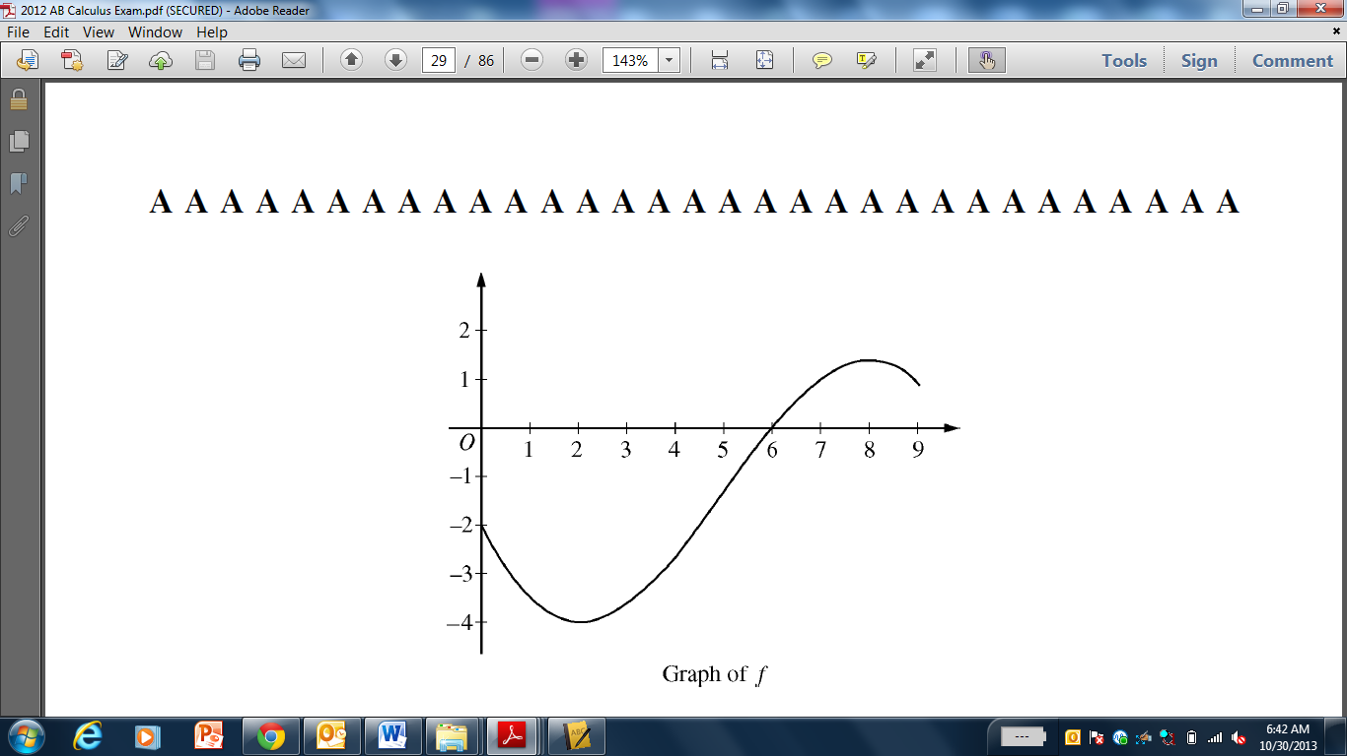

**3**. Let be a function defined on the closed interval with . The graph of , the

derivative of , is shown above.

(a) For , find all values at which has a relative minimum. Justify your answer.

(b) For , find all values of at which the graph of has a point of inflection. Justify your

answer.

(c) Find all intervals on which the graph of is both decreasing and concave up. Explain

your reasoning.

(d) Let be defined as . Find the equation of the line tangent to at .

__________________________________________________________________________________________

**4.** A particle moves along the -axis with velocity at time given by .

(a) Find the average acceleration of the particle on the interval .

(b) Find the instantaneous acceleration of the particle at time .

(c) Is the speed of the particle increasing at time ? Give a reason for your answer.

(d) Find all values of at which the particle changes direction. Justify your answer.

5. The twice-differentiable function is defined for all real numbers and satisfies the following conditions:

.

(a) Find the equation of the line tangent to at . Then use this tangent line to approximate the value of . Show the work that leads to your answer.

(b) The function is given by for all real numbers, where is a constant. Find and in terms of . Show the work that leads to your answers.

(c) The function is given by for all real numbers, where is a constant. Find and write an equation for the line tangent to the graph of at .

**6.** Let be a differentiable function for which and whose derivative is given by the equation for all .

(a) Find the -coordinate of the critical point of . Determine whether this point is a relative minimum, a relative maximum, or neither for the function . Justify your answer.

1. The graph of the function has exactly one point of inflection. Find the -coordinate of this

point.

1. Find all intervals for which the graph of is both increasing and concave up. Justify your

answer.

1. Evaluate

**END OF EXAM**